# Best Books to Read Right Now

**Home | Best of the Month | Book Lists | Form**

## Introduction

Welcome, dear friend, to your ultimate destination for uncovering the most captivating reads of the moment! Dive into our handpicked selection of books that promise to transport you to enchanting worlds, provoke thought-provoking reflections, and stir your imagination. Whether you're an avid reader seeking your next literary adventure or someone looking to explore new genres, our curated list ensures there's something for everyone. Let the pages of these exceptional books ignite your passion for reading and inspire unforgettable journeys of literary exploration. Discover your next literary obsession today!

## The Picture of dorian Gray

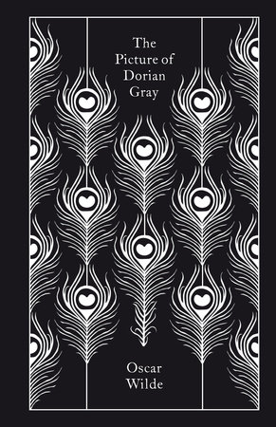

|  |  |
| --- | --- |
| Release Date | July 1890 |
| Title | The Picture of Dorian Gray |
| Author | Oscar Wilde |
| Goodreads’s rating | 4.1/5.0 |

**Book datasheet**

Oscar Wilde's only novel isn't your typical story. It's a dreamlike tale where a young man makes a Faustian bargain: eternal youth in exchange for his soul. Dorian Gray enjoys a life of indulgence, but the true cost is reflected in a hidden portrait that grotesquely transforms with each sin. This chilling Gothic horror, blending elements of French decadent fiction, remains a classic, showcasing Wilde's masterful storytelling and dark themes.

*ThePictureOfDorianGrayCover.jpg – Photo fo the cover of the book*

## The Metamorphosis

|  |  |
| --- | --- |
| Release Date | 1915 |
| Title | The Metamorphosis |
| Author | Franz Kafka |
| Goodreads’s rating | 3.9/5.0 |

**Book** **datasheet** 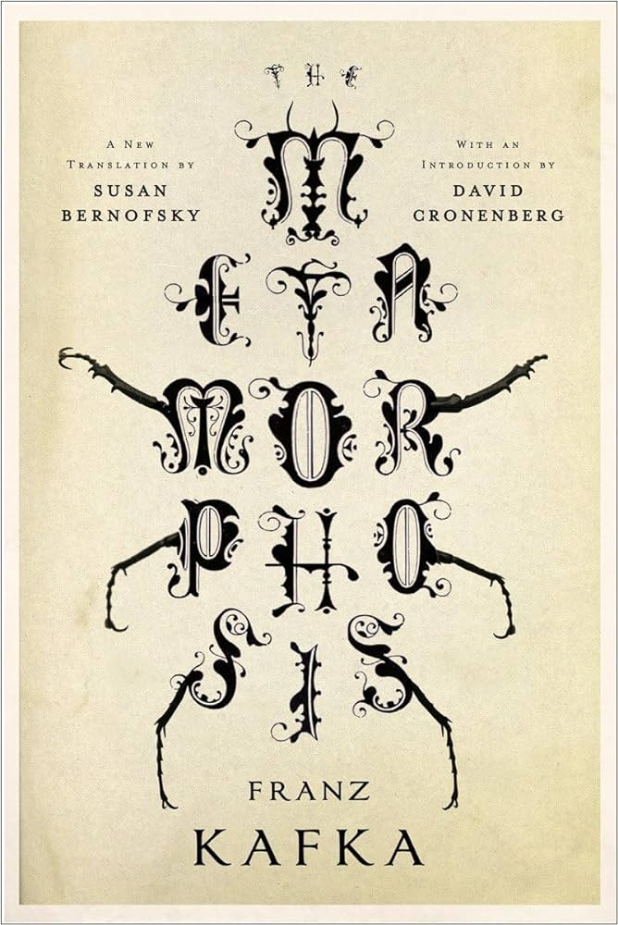

This is the story of a young man who, transformed overnight into a giant beetle-like insect, becomes an object of disgrace to his family, an outsider in his own home, a quintessentially alienated man. A harrowing—though absurdly comic—meditation on human feelings of inadequacy, guilt, and isolation, The Metamorphosis has taken its place as one of the most widely read and influential works of twentieth-century fiction.

*MetamorphosisCover.jpg – Photo fo the cover of the book*

### Audio Book – Chapter One

Embedded Audio (metamorphosisAudio.mp3)

## A book cover with text Description automatically generatedAtomic Habits

|  |  |
| --- | --- |
| Release Date | October 16, 2018 |
| Title | Atomic Habits |
| Author | James Clear |
| Goodreads’s rating | 4.4/5.0 |

**Book** **datasheet**

No matter your goals, Atomic Habits offers a proven framework for improving—every day. James Clear, one of the world's leading experts on habit formation, reveals practical strategies that will teach you exactly how to form good habits, break bad ones, and master the tiny behaviours that lead to remarkable results.

*AtomicHabitsCover.jpg – Photo fo the cover of the book*

### Video Summary

Embedded summary of the book

AtomicHabitsSum.mp4, AtomicHabitsSum.jpg

## Thinking, Fast and Slow

|  |  |
| --- | --- |
| Release Date | October 25, 2011 |
| Title | Thinking, Fast and Slow |
| Author | Daniel Kahneman |
| Goodreads’s rating | 4.2/5.0 |

**Book datasheet**  
Kahneman's "Thinking, Fast and Slow" explores two thinking systems: fast, intuitive System 1 and slow, logical System 2. He reveals how these systems shape our decisions and exposes biases that impact everything from finances to happiness. Understanding these systems helps us understand ourselves.

*ThinkingFastandSlowCover.jpg – Photo fo the cover of the book*

*Author: Midari Andrei (andreimidari.uni@gmail.com)  
H-1117 Budapest, Noname street 17*

# Best Books to Read Right Now

**Home | Best of the Month | Book Lists | Form**

## Best book of the April - Norwegian Wood

|  |  |
| --- | --- |
| Release Date | 1987 |
| Title | Norwegian wood |
| Author | Haruki Murakami |
| Goodreads’s rating | 4.0/5.0 |

**Book datasheet**

Toru, a quiet and preternaturally serious young college student in Tokyo, is devoted to Naoko, a beautiful and introspective young woman, but their mutual passion is marked by the tragic death of their best friend years before. Toru begins to adapt to campus life and the loneliness and isolation he faces there, but Naoko finds the pressures and responsibilities of life unbearable. As she retreats further into her own world, Toru finds himself reaching out to others and drawn to a fiercely independent and sexually liberated young woman.

*NorwegianWoodCover.jpg – Photo fo the cover of the book*

*Author: Midari Andrei (andreimidari.uni@gmail.com)  
H-1117 Budapest, Noname street 17*

# Best Books to Read Right Now

**Home | Best of the Month | Book Lists | Form**

## Books That Everyone Should Read At Least Once

* To Kill a Mockingbird
* 1984
* Animal Farm
* The Little Prince
* The Metamorphosis

## Best Books of the 20th Century

* Pride and Prejudice
* The Lord of the Rings
* The Picture of Dorian Gray
* Crime and Punishment
* Hamlet

## Best Non-Fiction

* Man’s Search for Meaning
* Sapiens: A Brief History of Humankind
* The Diary of a Young Girl Thinking, Fast and Slow
* Meditations

*Author: Midari Andrei (andreimidari.uni@gmail.com)  
H-1117 Budapest, Noname street 17*

# Best Books to Read Right Now

**Home | Best of the Month | Book Lists | Form**

## Send us your favorite book

Welcome to our book recommendation page! We're thrilled to hear about your favorite books and discover new literary treasures together. Share the magic of your beloved reads by filling out the form below. Whether it's an epic fantasy, a spine-tingling thriller, or a heartwarming romance, every recommendation adds to the richness of our community's reading experience. Let's celebrate the joy of storytelling and explore the endless possibilities within the pages of a book. Happy reading!

## Form to submit a book

Title

Goodreads’s rating

Short description

Rating

1 2 3 4 5

Your name

Your e-mail

Receive news letters from us!

Submit Reset

S

**Reset**

**Submit**

*Author: Midari Andrei (andreimidari.uni@gmail.com)  
H-1117 Budapest, Noname street 17*